**YR12 HUMAN BIOLOGY 2021 Unit 3**

**Task 1 Part B Test – Nervous System – MARKING KEY**

**Name:** …………………………………… Total Mark: /50

**Section One: Multiple Choice (10 marks)**

Place a ~~cross~~ through the selected letter.

1. A B C D 6. A B C D

2. A B C D 7. A B C D

3. A B C D 8. A B C D

4. A B C D 9. A B C D

5. A B C D 10. A B C D

**Section Two: Short answer (30 Marks)**

**Question 11 (9 marks)**

1. The nervous system has several different subdivisions which have quite specific functions. Using the table below, state one **functional** difference between the following parts of the nervous system.

(3 marks)

|  |  |
| --- | --- |
| **Two systems to compare** | **Main difference** |
| Afferent division vs efferent division of the peripheral nervous system | **Afferent carries impulse toward CNS and efferent carries impulse away from CNS**  ***1 mark for both. Do not award mark for only one half of the answer*** |
| Central nervous system compared to the peripheral nervous system | **CNS: coordination/modulation/integration of sensory input and motor output**  **Peripheral:**  **sends sensory input to CNS and takes motor output to muscles and glands**  ***1 mark for both. Do not award mark for only one half of the answer*** |
| Sympathetic vs Parasympathetic nervous system | **Sympathetic: stimulates “fight/flight” response**  **Parasympathetic: stimulates “rest/digest” response.**  ***1 mark for both. Do not award mark for only one half of the answer*** |

1. Describe the structure of the meninges (3 marks)

**3 layers:**

**Dura mater: fibrous layer that adheres closely to inside of skull (1)**

**Arachnoid mater: Mesh layer that provides space for CSF to flow (1)**

**Pia Mater: delicate layer closely adheres to surface of brain (1)**

***Note: only award mark if student has both name of layer and reasonable description.***

1. Describe the functions of the cerebrospinal fluid (3 marks)

**Protection – shock absorption during impact injuries OR blood brain barrier prevents pathogens from reaching brain (1)**

**Support– floats brain in cushion of fluid preventing it from pressing against skull (1)**

**Transport– transports gases, nutrients and wastes to and from brain tissue (1)**

***Note: only award mark if student has function and reasonable description.***

**Question 12 (7 marks)**

A reflex is a rapid response to a change in the internal and external environment.

The diagram below shows the main components of a reflex arc.

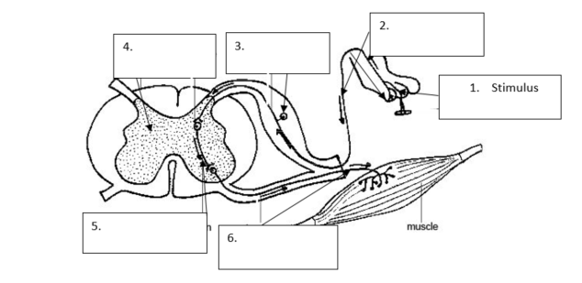

1. Identify the main components of the reflex arc indicated by the arrows by filling in the boxes on the diagram above. Number 1 has been done for you. (5 marks)

**2: sensory neuron 3: dorsal root ganglion 4: grey matter of spinal cord 5: interneuron/connector neuron 6: motor neuron**

1. Explain why the reflex arc is considered to be protective. (2 marks)

**Any 2 of:**

Protective reflex protects the body from injury or infection (1)

is rapid (1) and reduces harm (1)

**Question 13 (10 marks)**

Use the diagram below to answer the following questions.

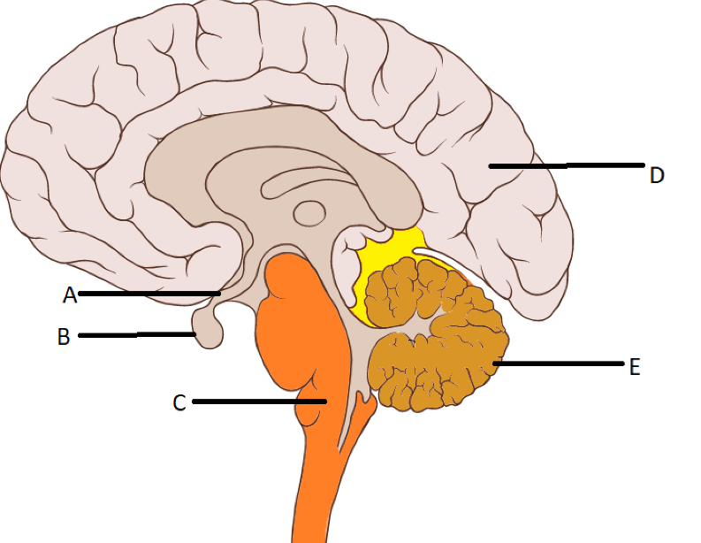

1. Name the following structures. (2 marks)

|  |  |
| --- | --- |
| **Description** | **Mark** |
| A: Hypothalamus | 1 |
| B: Pituitary Gland | 1 |
| **Total** | **2** |

1. Describe the function of the following structures. (4 marks)

|  |  |
| --- | --- |
| **Description** | **Mark** |
| C:  Controls (some) autonomic functions of the body  Including the respiratory centre/breathing/blood pressure/ heartrate | 1  1 |
| E:  Coordinates voluntary motor movements  Including posture/balance/coordination/speech/ or results in smooth and balanced motor function | 1  1 |
| **Total** | **4** |

1. D, the cerebrum is divided into four lobes. Name each of these lobes and state a function of each. (4 marks)

|  |  |
| --- | --- |
| **Description** | **Mark** |
| Frontal lobe  Voluntary motor movement/higher order processing/problem solving/ logical thinking/personality/memory *(1 mark for any one reasonable function)* | 1  1 |
| Temporal Lobe  Processing auditory information/spatial awareness/speech  *(1 mark for any one reasonable function)* | 1  1 |
| Parietal Lobe  Sensory processing/touch and temperature processing  *(1 mark for any one reasonable function)* | 1  1 |
| Occipital Lobe  Processing visual information/interpreting visual stimuli  *(1 mark for any one reasonable function)* | 1  1 |
| **Total** | **8** |

**Question 14 (4 marks)**

Below is an action potential graph, showing the outcome from two different stimuli on the same neuron. Looking at the graph below, answer the questions that follow.

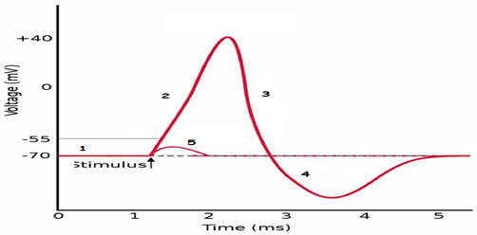

1. The first stimulus resulted in the line labelled with the number 5. Explain why the potential difference quickly returned to -70mV. (2 marks)

*Student MUST have the following:*

* *The stimulus provided did not exceed the specific membrane potential threshold. (1 mark)*

*Student may have either of the following:*

* *Insufficient sodium ion gated channels were stimulated to open (1 mark) OR*

*Insufficient sodium ions moved across the membrane (1 mark)*

1. The second stimulus resulted in the line labelled with the numbers 2, 3 and 4. State TWO events related to the nerve impulse that could not possibly occur during the phases shown by the sections labelled 2, 3 and 4.

(2 marks)

* *The impulse cannot flow backwards. (1 mark)*

*A new action potential cannot be stimulated. (1 mark)*

**Section Three: Extended Answer (15 marks)**

**Question 15**

1. Caffeine has been known to help long haul truck drivers carry their load over long distances with minimum sleep. Caffeine results in increased neurotransmitter at some synapses.

Explain how an excitatory nerve impulse is transmitted across a synaptic gap. (9 marks)

**The action potential reaches the axon terminal (1)**

**This stimulates Ca2+ channels in the membrane to open (1)**

**This stimulates vesicles containing neurotransmitter (1)**

**To move to the end of the axon terminal and release their contents (1)**

**The neurotransmitter diffuses across the synaptic cleft (1)**

**And binds to receptor sites on the dendrite of the post synaptic neuron (1)**

**The neurotransmitter/receptor complex opens Na+ channels (1) on the dendrite.**

**This allows Na+ to flood in (1) triggering a new wave of depolarisation (1) in the post-synaptic neuron.**

***Students must have key vocabulary in place to receive a mark for each statement.***

1. Some neurotransmitters have an inhibitory effect. Describe the effect they have on receptors at the post synaptic membrane, to cause this effect. (6 marks)

**Neurotransmitters bind to specific receptors (1) on the post synaptic membrane (1)**

**These receptors then cause potassium channels to open (1)**

**Potassium floods into the membrane (1), causing local hyperpolarisation (1)**

**This increases the stimulation required to reach the threshold for an action potential to occur, therefore having an inhibitory effect. (1)**